

Inventory Management Database
Meghavath Harshit (23CSB0B65)

Introduction: What is Inventory Management System?

An Inventory/Stock Management System is a software application designed to track, organize, and manage the flow of goods throughout an organization. At its core, it maintains a centralized database of all items in stock, including details such as product identifiers, descriptions, quantities on hand, reorder levels, unit costs, and supplier information. By providing real-time visibility into inventory levels, locations, and movements, the system helps businesses ensure they have the right products available at the right time, while minimizing excess stock and stockouts.

Problem Statement

Aim: To develop Inventory Management System for a grocery store. The primary responsibilities of this system include:
- Store and update product details (ID, description, category, unit price, stock levels).
- Log every receipt, issue, adjustment, and transfer to ensure accurate on-hand quantities.
- Validate availability, reserve stock, adjust quantities, and record order details seamlessly.
- Store supplier information, track lead times, and record order status from “placed” through “received.”
- Use DBMS constraints, transactions, and audit trails to prevent overselling, duplicate orders, or orphan records.

Key features of the Inventory Management System

Centralized Product Catalogue:
Maintain a single Product table that stores SKU (Stock-Keeping Unit) details (ID, name, category, unit price), current UnitsInStock, and ReorderLevel—ensuring all modules refer to the same master data.

Real-Time Stock Tracking
Use the InventoryTransaction table to log every receipt, issue, adjustment, or transfer with timestamps and reference IDs (POID/SOID), so on-hand quantities in Product.UnitsInStock are always up to date.

Automated Reorder & Procurement
Monitor UnitsInStock vs. ReorderLevel and trigger new PurchaseOrder records to suppliers automatically; line-items live in PurchaseOrderDetail linking each order to specific products and quantities.

Sales Order Processing
Capture customer orders in SalesOrder and their line-items in SalesOrderDetail; upon confirmation, decrement UnitsInStock and insert a matching “ISSUE” transaction to maintain consistency.

Audit Trail & Data Integrity
Enforce referential integrity via foreign keys and record every movement in InventoryTransaction, enabling full traceability (who, when, why) and preventing orphaned or inconsistent stock records.

Reporting & Analytics Dashboards
Leverage your normalized schema—Product, PurchaseOrderDetail, SalesOrderDetail, and InventoryTransaction—to generate reports on stock valuation, turnover rates, low-stock alerts, top-selling items, and supplier lead-time analysis.

Entity-Relationship Model

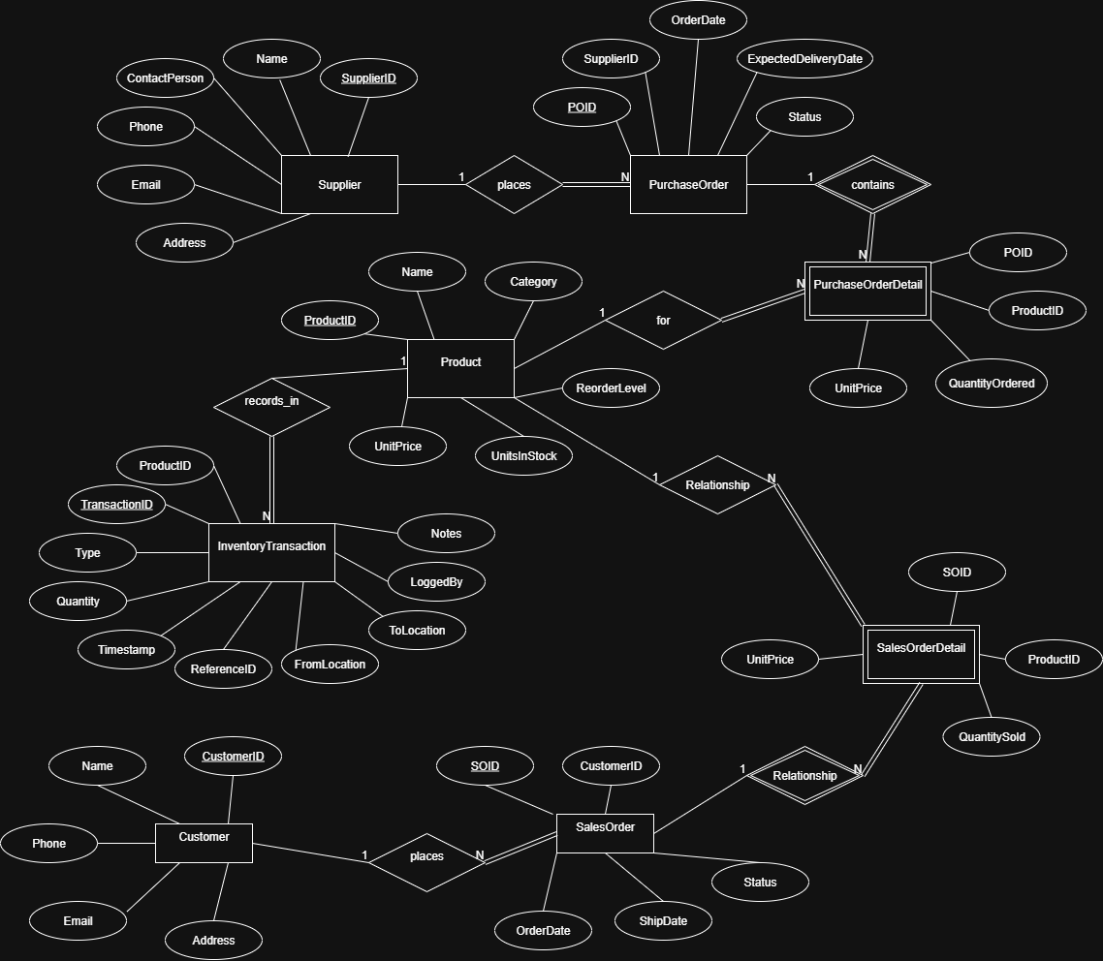

Entities
Product: Central catalog of items.
Attributes: ProductID, Name, Category, UnitPrice, UnitsInStock, ReorderLevel
Primary key: ProductID
Supplier: Vendors who supply products.
Attributes: SupplierID, Name, ContactPerson, Phone, Email, Address
Primary key: SupplierID

PurchaseOrder : Orders placed to suppliers.
Attributes: POID, SupplierID, OrderDate, ExpectedDeliveryDate, Status
Primary key: POID

PurchaseOrderDetail (weak entity) : Line‐items within each PurchaseOrder.
Attributes: POID, ProductID, QuantityOrdered, UnitPrice
Partial key: ProductID
Primary key: POID, ProductID
Totally depends on: PurchaseOrder

Customer : Buyers who place sales orders.
Attributes: CustomerID, Name, Phone, Email, Address
Primary key: CustomerID

SalesOrder : Orders placed by customers.
Attributes: SOID, CustomerID, OrderDate, ShipDate, Status
Primary key: SOID

SalesOrderDetail (weak entity) : Line‐items within each sales order.
Attributes: SOID, ProductID, QuantitySold, UnitPrice
Partial key: ProductID
Primary key: SOID, ProductID
Totally depends on: SalesOrder

InventoryTransaction: Audit of every stock movement.
Attributes: TransactionID, ProductID, Type, Quantity, TransactionTime, ReferenceID, FromLocation, ToLocation, LoggedBy, Notes
Primary key: TransactionID

Relationships

Places
Between: Supplier (partially participates) and PurchaseOrder (totally participates)
Cardinality: one Supplier to many PurchaseOrders
Assumption: Every PurchaseOrder must reference a Supplier, but a Supplier may exist without ever having a PurchaseOrder.
As it is one-to-many, Supplier.SupplierID (PK) is added as a foreign key in PurchaseOrder.SupplierID.

Contains
Between: PurchaseOrder (partially participates) and PurchaseOrderDetail (totally participates)
Cardinality: one PurchaseOrder to many PurchaseOrderDetail rows
Assumption: Each line-item (PurchaseOrderDetail) cannot exist without its parent PurchaseOrder, although a PurchaseOrder may temporarily be created before items are added.
As an identifying (weak) relationship, PurchaseOrder.POID (PK) appears in PurchaseOrderDetail both as part of its composite PK (POID, ProductID) and as a foreign key.
For
Between: PurchaseOrderDetail (totally participates) and Product (partially participates)
Cardinality: many PurchaseOrderDetail rows to one Product
Assumption: Every line-item must reference an existing Product, but a Product may never be ordered.
As many-to-one, Product.ProductID (PK) is added as a foreign key in PurchaseOrderDetail.ProductID.

Places
Between: Customer (partially participates) and SalesOrder (totally participates)
Cardinality: one Customer to many SalesOrders
Assumption: Each SalesOrder must reference a Customer, but you can have customer records without any orders.
Customer.CustomerID (PK) is added as a foreign key in SalesOrder.CustomerID.

Contains
Between: SalesOrder (partially participates) and SalesOrderDetail (totally participates)
Cardinality: one SalesOrder to many SalesOrderDetail rows
Assumption: Each sales line-item must belong to a SalesOrder, though a SalesOrder may initially be created without items.
As an identifying (weak) relationship, SalesOrder.SOID (PK) appears in SalesOrderDetail as part of its composite PK (SOID, ProductID) and as a foreign key.

For
Between: SalesOrderDetail (totally participates) and Product (partially participates)
Cardinality: many SalesOrderDetail rows to one Product
Assumption: Every line-item must reference a valid Product, but some Products may never be sold.
Product.ProductID (PK) is added as a foreign key in SalesOrderDetail.ProductID.

Records_in
Between: Product (partially participates) and InventoryTransaction (totally participates)
Cardinality: one Product to many InventoryTransactions
Assumption: Each stock movement must reference a Product, but a Product may have no transactions yet (never moved).
Product.ProductID (PK) is added as a foreign key in InventoryTransaction.ProductID.

Relational schema and Normalization

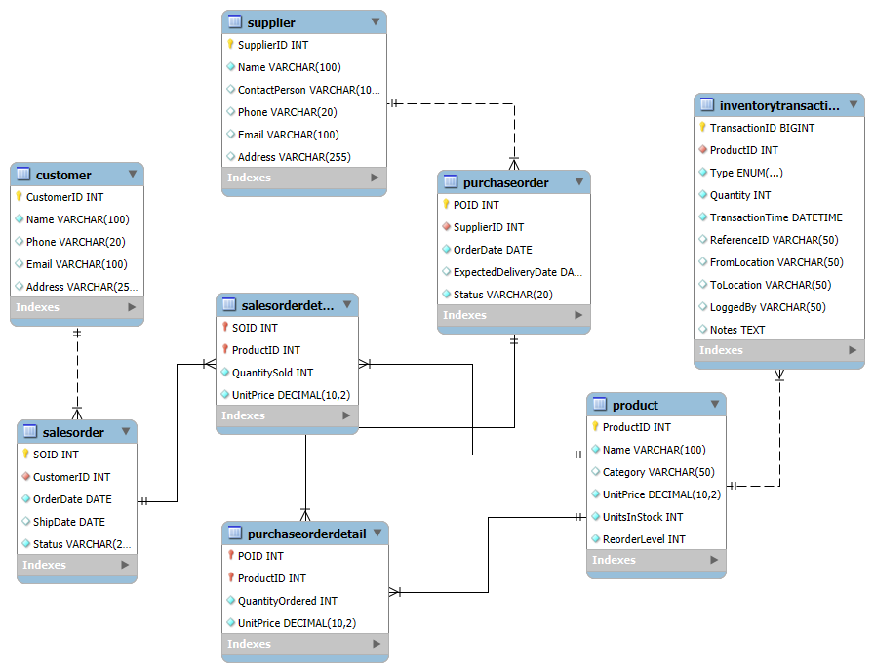

- Product
FDs:
ProductID → Name, Category, UnitPrice, UnitsInStock, ReorderLevel
Primary Key: ProductID
Normal Form: Relation is in BCNF.

- Supplier
FDs:
SupplierID → Name, ContactPerson, Phone, Email, Address
Primary Key: SupplierID
Normal Form: Relation is in BCNF.

- PurchaseOrder
FDs:
POID → SupplierID, OrderDate, ExpectedDeliveryDate, Status
Primary Key: POID
Normal Form: Relation is in BCNF.

- PurchaseOrderDetail
FDs:
(POID, ProductID) → QuantityOrdered, UnitPrice
Primary Key: (POID, ProductID)
Normal Form: Relation is in BCNF.

- Customer
FDs:
CustomerID → Name, Phone, Email, Address
Primary Key: CustomerID
Normal Form: Relation is in BCNF.

- SalesOrder
FDs:
SOID → CustomerID, OrderDate, ShipDate, Status
Primary Key: SOID
Normal Form: Relation is in BCNF.

- SalesOrderDetail
FDs:
(SOID, ProductID) → QuantitySold, UnitPrice
Primary Key: (SOID, ProductID)
Normal Form: Relation is in BCNF.

- InventoryTransaction
FDs:
TransactionID → ProductID, Type, Quantity, TransactionTime,
ReferenceID, FromLocation, ToLocation,
LoggedBy, Notes
Primary Key: TransactionID
Normal Form: Relation is in BCNF.

SQL Queries to create Tables

CREATE TABLE Product (
ProductID INT PRIMARY KEY,
Name VARCHAR(100) NOT NULL,
Category VARCHAR(50),
UnitPrice DECIMAL(10,2) NOT NULL,
UnitsInStock INT NOT NULL DEFAULT 0,
ReorderLevel INT NOT NULL DEFAULT 0
);

CREATE TABLE Supplier (
SupplierID INT PRIMARY KEY,
Name VARCHAR(100) NOT NULL,
ContactPerson VARCHAR(100),
Phone VARCHAR(20),
Email VARCHAR(100),
Address VARCHAR(255)
);

CREATE TABLE PurchaseOrder (
POID INT PRIMARY KEY,
SupplierID INT NOT NULL,
OrderDate DATE NOT NULL,
ExpectedDeliveryDate DATE,
Status VARCHAR(20) NOT NULL DEFAULT 'PLACED',
FOREIGN KEY (SupplierID)
REFERENCES Supplier(SupplierID)
ON UPDATE CASCADE
ON DELETE RESTRICT
);

CREATE TABLE PurchaseOrderDetail (
POID INT NOT NULL,
ProductID INT NOT NULL,
QuantityOrdered INT NOT NULL,
UnitPrice DECIMAL(10,2) NOT NULL,
PRIMARY KEY (POID, ProductID),
FOREIGN KEY (POID)
REFERENCES PurchaseOrder(POID)
ON UPDATE CASCADE
ON DELETE CASCADE,
FOREIGN KEY (ProductID)
REFERENCES Product(ProductID)
ON UPDATE CASCADE
ON DELETE RESTRICT
);

CREATE TABLE Customer (
CustomerID INT PRIMARY KEY,
Name VARCHAR(100) NOT NULL,
Phone VARCHAR(20),
Email VARCHAR(100),
Address VARCHAR(255)
);

CREATE TABLE SalesOrder (
SOID INT PRIMARY KEY,
CustomerID INT NOT NULL,
OrderDate DATE NOT NULL,
ShipDate DATE,
Status VARCHAR(20) NOT NULL DEFAULT 'PENDING',
FOREIGN KEY (CustomerID)
REFERENCES Customer(CustomerID)
ON UPDATE CASCADE
ON DELETE RESTRICT
);

CREATE TABLE SalesOrderDetail (
SOID INT NOT NULL,
ProductID INT NOT NULL,
QuantitySold INT NOT NULL,
UnitPrice DECIMAL(10,2) NOT NULL,
PRIMARY KEY (SOID, ProductID),
FOREIGN KEY (SOID)
REFERENCES SalesOrder(SOID)
ON UPDATE CASCADE
ON DELETE CASCADE,
FOREIGN KEY (ProductID)
REFERENCES Product(ProductID)
ON UPDATE CASCADE
ON DELETE RESTRICT
);

CREATE TABLE InventoryTransaction (
TransactionID BIGINT AUTO_INCREMENT PRIMARY KEY,
ProductID INT NOT NULL,
Type ENUM('RECEIPT','ISSUE','ADJUST','TRANSFER') NOT NULL,
Quantity INT NOT NULL,
TransactionTime DATETIME NOT NULL DEFAULT CURRENT_TIMESTAMP,
ReferenceID VARCHAR(50),
FromLocation VARCHAR(50),
ToLocation VARCHAR(50),
LoggedBy VARCHAR(50),
Notes TEXT,
FOREIGN KEY (ProductID)
REFERENCES Product(ProductID)
ON UPDATE CASCADE
ON DELETE RESTRICT
);

SQL queries to insert data

-- 1. PRODUCTS
INSERT INTO Product (ProductID, Name, Category, UnitPrice, UnitsInStock, ReorderLevel) VALUES
(1, 'Widget A', 'Hardware', 10.00, 5, 10),
(2, 'Gadget B', 'Electronics', 25.00, 20, 15),
(3, 'Tool C', 'Hardware', 15.00, 0, 5),
(4, 'Part D', 'Components', 5.50, 50, 20),
(5, 'Device E', 'Electronics', 100.00, 2, 5);

-- 2. SUPPLIERS
INSERT INTO Supplier (SupplierID, Name, ContactPerson, Phone, Email, Address) VALUES
(1, 'Acme Supplies', 'John Doe', '123-4567', 'acme@example.com', '123 Main St'),
(2, 'Global Parts', 'Jane Smith','987‑6543', 'global@example.com', '456 Elm St');

-- 3. PURCHASE ORDERS (PO)
INSERT INTO PurchaseOrder (POID, SupplierID, OrderDate, ExpectedDeliveryDate, Status) VALUES
(1001, 1, '2025‑07‑01', '2025‑07‑05', 'PLACED'),
(1002, 2, '2025‑07‑02', '2025‑07‑07', 'RECEIVED');

-- 4. PURCHASEORDERDETAIL (line‑items for POs)
INSERT INTO PurchaseOrderDetail (POID, ProductID, QuantityOrdered, UnitPrice) VALUES
(1001, 1, 20, 10.00),
(1001, 3, 10, 15.00),
(1002, 4, 30, 5.50);

-- 5. CUSTOMERS
INSERT INTO Customer (CustomerID, Name, Phone, Email, Address) VALUES
(1, 'Alice', '555-0001', 'alice@domain.com', '789 Maple St'),
(2, 'Bob', '555-0002', 'bob@domain.com', '321 Oak St');

-- 6. SALES ORDERS (SO)
INSERT INTO SalesOrder (SOID, CustomerID, OrderDate, ShipDate, Status) VALUES
(2001, 1, '2025‑07‑03', '2025‑07‑04', 'PENDING'),
(2002, 2, '2025‑07‑04', NULL, 'PENDING');

-- 7. SALESORDERDETAIL (line‑items for SOs)
INSERT INTO SalesOrderDetail (SOID, ProductID, QuantitySold, UnitPrice) VALUES
(2001, 2, 5, 25.00),
(2001, 5, 2,100.00),
(2002, 1, 3, 10.00),
(2002, 3, 1, 15.00);

INSERT INTO InventoryTransaction (
ProductID, Type, Quantity, TransactionTime, ReferenceID,
FromLocation, ToLocation, LoggedBy, Notes
) VALUES
(1, 'RECEIPT', 20, '2025-07-05 10:00:00', '1001', NULL, NULL, 'system', 'PO #1001 receipt, Widget A'),
(3, 'RECEIPT', 10, '2025-07-05 10:05:00', '1001', NULL, NULL, 'system', 'PO #1001 receipt, Tool C'),
(4, 'RECEIPT', 30, '2025-07-07 09:00:00', '1002', NULL, NULL, 'system', 'PO #1002 receipt, Part D'),
(2, 'ISSUE', 5, '2025-07-04 15:00:00', '2001', NULL, NULL, 'system', 'SO #2001 issue, Gadget B'),
(5, 'ISSUE', 2, '2025-07-04 15:05:00', '2001', NULL, NULL, 'system', 'SO #2001 issue, Device E'),
(1, 'ISSUE', 3, '2025-07-05 11:00:00', '2002', NULL, NULL, 'system', 'SO #2002 issue, Widget A'),
(3, 'ISSUE', 1, '2025-07-05 11:05:00', '2002', NULL, NULL, 'system', 'SO #2002 issue, Tool C'),
(2, 'ADJUST', -2, '2025-07-06 12:00:00', 'ADJ100', NULL, NULL, 'operator', 'Cycle count correction, Gadget B'),
(2, 'TRANSFER', 10, '2025-07-06 13:00:00', 'TRF200', 'WH1', 'WH2', 'operator', 'Transfer Gadget B WH1->WH2');

-- AUTOMATION TRIGGERS
DELIMITER //

-- Trigger 1: Auto-update Stock on PURCHASE (Receipts)
CREATE TRIGGER AfterPurchaseOrderInsert
AFTER INSERT ON PurchaseOrderDetail
FOR EACH ROW
BEGIN
-- Increase stock in Product table
UPDATE Product
SET UnitsInStock = UnitsInStock + NEW.QuantityOrdered
WHERE ProductID = NEW.ProductID;

-- Log the transaction automatically
INSERT INTO InventoryTransaction (ProductID, Type, Quantity, ReferenceID, LoggedBy, Notes)
VALUES (NEW.ProductID, 'RECEIPT', NEW.QuantityOrdered, CAST(NEW.POID AS CHAR(50)), 'System_Trigger', CONCAT('Auto-Receipt for PO #', NEW.POID));
END; //

-- Trigger 2: Auto-update Stock on SALE (Issues)
CREATE TRIGGER AfterSalesOrderInsert
AFTER INSERT ON SalesOrderDetail
FOR EACH ROW
BEGIN
-- Decrease stock in Product table
UPDATE Product
SET UnitsInStock = UnitsInStock - NEW.QuantitySold
WHERE ProductID = NEW.ProductID;

-- Log the transaction automatically
INSERT INTO InventoryTransaction (ProductID, Type, Quantity, ReferenceID, LoggedBy, Notes)
VALUES (NEW.ProductID, 'ISSUE', NEW.QuantitySold, CAST(NEW.SOID AS CHAR(50)), 'System_Trigger', CONCAT('Auto-Issue for SO #', NEW.SOID));
END; //

DELIMITER ;

Database in action

- Low-Stock Products Report
List all low-stock products that need reordering.

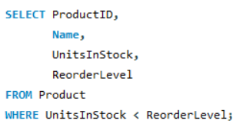
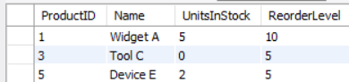

- Purchase Order Summary
Show each purchase order with its supplier name and total number of line-items.

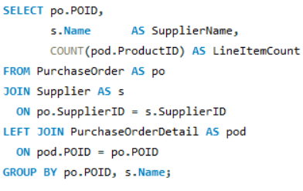

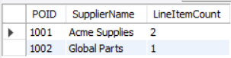

- Total Purchases by Product
Compute total quantity ordered per product across all purchase orders.

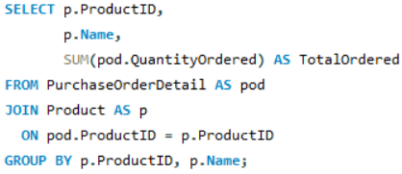

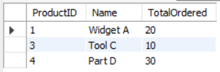

- Sales Order Revenue
List sales orders along with their total sales amount.

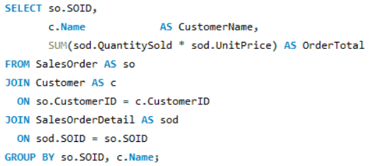

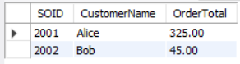

- Unsold Products Finder
Find products that have never been sold.

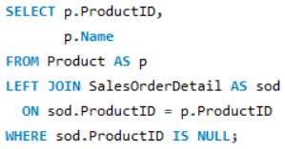

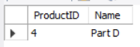

- Recent Transaction Log
Retrieve the last 5 inventory transactions for a given product (e.g. ProductID = 2).

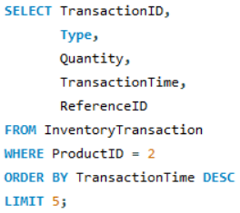

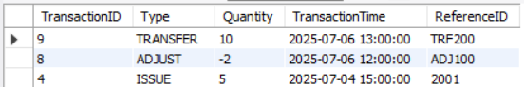

- Inventory Valuation by Category
Calculate current stock value per category.

